Vision 2030 is a transformative blueprint aimed at fostering sustainable economic growth, innovation, and social development. Our commitment to Vision 2030 aligns with these goals, driving us to deliver services and solutions that contribute to a prosperous and resilient future.


P


E
L
I
F
O
R
P

NAWAF ELITE Construction
Building Excellence Through Quality, Integrity, and Innovation.
ELITE Establishment For Contracting
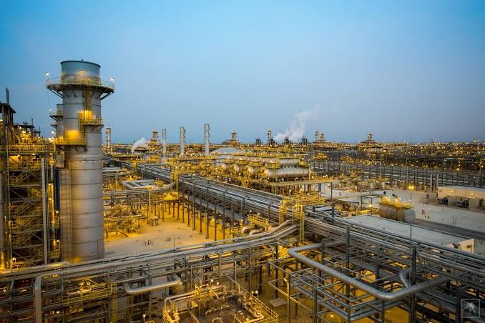

Table of Contents
01
Our Mission and Vision

Introduction

02
Our Services

03
Industrial Services

04
Trading Services

05
Manpower Services

06
Equipment Rental

07
Backfilling Materials
08
Our Certifications

09
Our Clients

10
Projects Gallery

11
NAWAF ELITE ESTABLISHMENT FOR CONSTRUCTING
PAGE 01



Introduction
Nawaf Elite Establishment for Constructing is a trusted provider of comprehensive business solutions designed to support and enhance your operations across multiple industries. With years of experience and a commitment to quality, reliability, and customer satisfaction, we deliver tailored services that help businesses achieve operational excellence and sustainable growth.

- Building Trust, Delivering Excellence Since 1997
Founded in 1997, Nawaf Elite Establishment for Constructing (NEEC) has earned a strong reputation as a trusted partner in the construction and infrastructure sector, proudly serving the Eastern Province and beyond. Backed by decades of reliable performance, NEEC delivers an integrated range of services for both commercial and residential clients.

Our core expertise spans the construction of modern facilities, civil works and maintenance, electrical and instrumentation systems, mechanical installation, and piping and fabrication — along with custom-built infrastructure solutions designed around each client's needs.

Beyond construction, NEEC operates four complementary business lines that support the full lifecycle of industrial and infrastructure projects:
- Manpower Services – Skilled, semi-skilled, and unskilled personnel supplied flexibly to help clients sustain productivity.
- Equipment Rental – A well-maintained, safety-checked fleet of machinery and tools available on flexible terms.
- Industrial Services – Maintenance, plant shutdown support, and on-site technical expertise to keep operations running smoothly.
- Trading Services – Sourcing and supply of industrial goods, construction materials, and consumables from trusted local and international partners.

NEEC is also recognized for delivering high-quality security infrastructure solutions in full compliance with industry safety standards.

NAWAF ELITE ESTABLISHMENT FOR CONSTRUCTING
PAGE 02

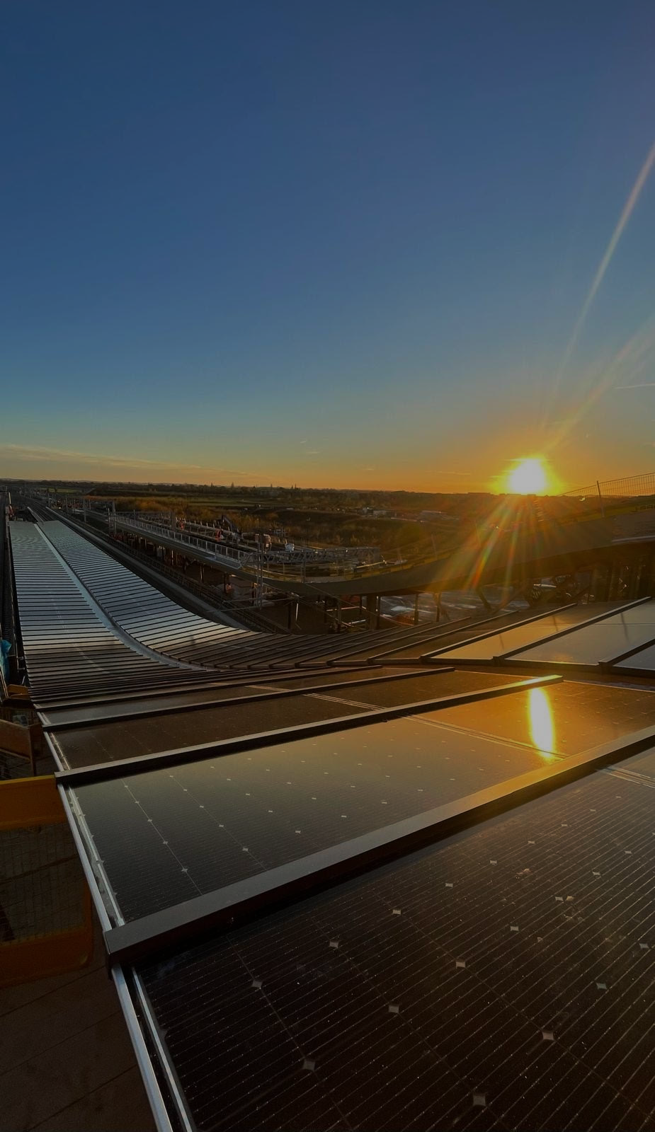
add a
Empowering Projects Through neec, Precision, and Trust
Nawaf Elite Establishment for Constructing (NEEC) is a trusted name in construction and infrastructure development, proudly serving the Eastern Province and beyond. We deliver a comprehensive range of services tailored to the diverse needs of both commercial and residential sectors, with a steadfast commitment to quality, reliability, and client satisfaction.
- What We Do
At NEEC Ltd, we offer a broad spectrum of services designed to support complex and high-impact projects, including:
- Commercial & Residential Construction
- Preventive Maintenance for Industrial Facilities
- Earthworks & Asphalting
- Custom Infrastructure Projects (e.g., duct-bank manholes, hand holes, access roads)
- Security Installations (fencing systems, security poles, hydraulic/manual bollards)

- Support Services
Beyond construction, NEEC provides essential support services to enhance operational efficiency for clients across various industries:
- Manpower Supply – Skilled and semi-skilled personnel for construction, industrial, and maintenance projects.
- Equipment Rental – A wide range of well-maintained construction and industrial machinery available for short- and long-term rental.
- Trading Services – Procurement and supply of construction materials, industrial tools, and related equipment, ensuring timely delivery and quality assurance.

- Why Choose NEEC?
At Nawaf Elite Est Co, we are driven by a commitment to:
- NEEC – Leveraging modern methods and smart solutions
- Excellence – Upholding the highest standards in every task
- Reliability – Delivering consistent results you can count on
- Client Focus – Providing tailored solutions to meet every unique need

Our proven track record, experienced team, and customer-first approach make NEEC a dependable partner in shaping infrastructure and enabling progress across the region.
NAWAF ELITE ESTABLISHMENT FOR CONSTRUCTING
PAGE 03


Our Mission and Vision
To empower businesses by providing high-quality, reliable services and solutions that drive efficiency, productivity, and success—while fostering long-term partnerships based on trust and integrity.

- Mission: Delivering Excellence Through Integrity and neec
At NEEC Ltd, our mission is to set new standards of excellence in construction, infrastructure, and support services by consistently delivering reliable, high-quality solutions that meet the evolving needs of our customers and communities. We strive to outperform our competitors not just through superior results, but by fostering trust, accountability, and long-term partnerships.

We are committed to conducting our business with integrity and professionalism in everything we do. Our customers are at the heart of our operations, and we aim to exceed their expectations by being responsive, innovative, and attentive to every detail. We believe that sustainable success is built on mutual respect, and we extend that principle to all our stakeholders—including our employees, suppliers, and strategic partners—treating each with fairness, transparency, and the consideration we expect for ourselves.

Through continuous improvement, ethical leadership, and a strong sense of social responsibility, we aim to contribute meaningfully to the development of our region while empowering our team members to grow and thrive. Together, we are building not just structures, but trust, opportunity, and a better future for all.

- Vision: Shaping a Sustainable Future Built on Trust and Performance
To be a leading service provider recognized for innovation, excellence, and commitment to delivering value in manpower, equipment, industrial, and trading services across the region.
NAWAF ELITE ESTABLISHMENT FOR CONSTRUCTING
PAGE 04

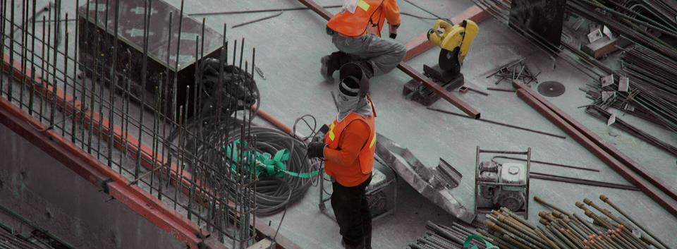
Our Services


To empower businesses by providing high-quality, reliable services and solutions that drive efficiency, productivity, and success—while fostering long-term partnerships based on trust and integrity.

We deliver integrated industrial support solutions for construction, oil & gas, petrochemical, power, and infrastructure projects. Our services are executed by experienced personnel under rigorous HSE, quality, and operational control procedures to support safe, efficient, and compliant project delivery.
Industrial Services
Trading Services

We supply backfilling materials for construction, infrastructure, utility, and site development projects in accordance with project specifications and approved quality requirements. Delivery logistics are coordinated to maintain continuity of work fronts and support uninterrupted site operations
We offer construction and industrial equipment rental on both short-term and long-term arrangements. Equipment is maintained under planned maintenance programs and supported by responsive operational coordination to maximize availability, reliability, and cost efficiency.
Backfilling Materials Supply
Equipment Rental Services

Manpower Supply Services

We supply skilled, semi-skilled, and general manpower across industrial and construction disciplines in accordance with client requirements and project specifications. Workforce mobilization, documentation, supervision coordination, and compliance support are managed through structured recruitment and deployment processes.

We provide sourcing and supply of industrial, electrical, mechanical, and construction materials through an established procurement network. Our trading operations emphasize product conformity, competitive commercial terms, traceability, and dependable delivery performance.

NAWAF ELITE ESTABLISHMENT FOR CONSTRUCTING
PAGE 05
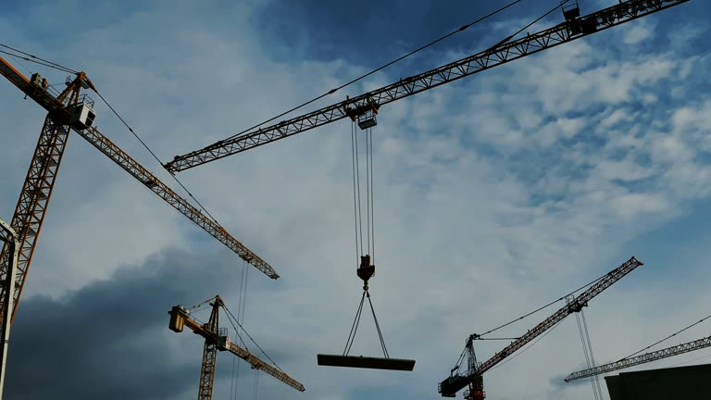

INTERIM INNOVATION COM
PAGE 06

NAWAF ELITE ESTABLISHMENT FOR CONSTRUCTING
OUR SKILLED MANPOWER SUPPLY INCLUDES
Complete Workforce Solutions — Skilled Trades, Technical Staff & Support Personnel for Civil, Mechanical, Electrical & Instrumentation Projects
  SUPERVISORS & FOREMEN
  Foreman-Civil
  Foreman-Mechanical
  Foreman-Electrical
  Lifting Supervisor
  Steel Structure Supervisors
  Piping Supervisors & Foremen
  Mechanical Supervisors & Foremen
  HVAC Supervisors & Foremen
  Civil Supervisors & Foremen
  Instrumentation Supervisors & Foremen
  Electrical Supervisors & Foremen
  Millwright Technicians & Foremen
  Scaffolding Supervisors & Foremen (TUV Certified)
  Pre-Commissioning Supervisors
  Commissioning Supervisors
  ELECTROMECHANICAL WORKFORCE
  Electrical Technician
  Mechanical Technician
  Testing & Commissioning Technician
  Mechanical Fitter
  Diesel Mechanic
  Welder
  Scaffolding Inspector
  Welding Inspectors
  Instrument Technicians
  Millwright Technicians
  TIG Welders (SS/CS)
  ARC Welders
  SIG Welders
  Structural Fabricators
  ELECTROMECHANICAL WORKFORCE
  Electrical Technician
  Mechanical Technician
  Testing & Commissioning Technician
  Mechanical Fitter
  Diesel Mechanic
  Welder
  Scaffolding Inspector
  Welding Inspectors
  Instrument Technicians
  Millwright Technicians
  TIG Welders (SS/CS)
  ARC Welders
  SIG Welders
  Structural Fabricators
  Piping Fabricators
  ADMINISTRATIVE STAFF
  Executive Secretaries
  Data Entry Operators
  Document Controllers
  Office Boys
  Administrative Assistants
  Computer Operators
  AutoCAD Technicians (Civil & Mechanical)
  Permit Receivers
  Time Keepers
  Janitors
  Telephone Operators
  Office Drivers
  HELPERS & LABOUR
  Plumber Helper
  Electrician Helper
  Scaffolder Helper
  Draftsman Helper
  Mason Helper
  Carpenter Helper
  Steel Fixer Helper
  Painter Helper
  Rigger Helper
  Welder Helper
  Piping Fabricator Helper
  Mechanical Fitter Helper
  Electrical Technician Helper
  Mechanical Engineer Helper
  Piping Engineer Helper
  CIVIL WORKFORCE
  Plumbers
  Electricians
  Scaffolders
  Draftsmen
  Masons
  Carpenter
  Steel Fixer
  Painter
  RIGGERS
  Rigger-I
  Rigger-II
  Rigger-III LEVEL

YOUR TRUSTED MANPOWER SUPPLY PARTNER • Skilled · Reliable · Ready to Deploy

Industrial Services


Our Industrial Services are designed to support the operational efficiency and safety of manufacturing and processing facilities. We offer a comprehensive range of solutions including maintenance support, plant shutdown assistance, equipment cleaning, and on-site technical services.
- Enhancing Operational Efficiency and Safety in Industrial Environments
At NEEC Ltd, our Industrial Services are built to support the performance, safety, and continuity of operations across manufacturing, processing, and industrial facilities. We understand the critical importance of minimizing downtime and maintaining safe, efficient workflows—and our services are designed to do just that.
We provide a comprehensive range of technical and support solutions tailored to meet the demands of high-performance industrial operations, whether during routine activity or critical plant shutdowns.

- Our Core Offerings Include:
- Preventive and Corrective Maintenance Support
- Plant Shutdown and Turnaround Services
- Industrial Equipment Cleaning and Decontamination
- On-Site Technical Support and Skilled Manpower
- Inspection, Monitoring, and Minor Repair Services
- Civil construction & maintenance, Electrical and instrumentation, mechanical activity and installation piping and fabrication activities

- Why Choose NEEC for Industrial Services?
- Experienced Teams – Skilled professionals familiar with complex industrial environments.
- Customized Solutions – Tailored to your facility's specific processes and safety standards.
- Rapid Response – Quick deployment to reduce operational downtime.
- Safety-First Approach – Adherence to strict industry regulations and best practices.
- End-to-End Support – From planning to execution and reporting.

Whether you need routine support, emergency response, or full-scale shutdown assistance, NEEC is your trusted partner for safe, efficient, and effective industrial service delivery.

Keep your operations running smoothly—with NEEC Ltd by your side.

PAGE 07
NAWAF ELITE ESTABLISHMENT FOR CONSTRUCTING


NAWAF ELITE ESTABLISHMENT FOR CONSTRUCTING
PAGE 08

Our Trading Services connect businesses with high-quality products and materials sourced from trusted local and international suppliers. We specialize in the procurement and supply of industrial goods, equipment, and consumables across various sectors.

- Supplying Quality Products and Materials to Power Your Operations

At NEEC Ltd, our Trading Services are designed to connect businesses with high-quality products, equipment, and materials sourced from reliable local and international suppliers. We specialize in the procurement and supply of industrial goods, ensuring that our clients receive the right products—on time and within budget—to keep their operations running efficiently.
With a strong network of vetted manufacturers and distributors, we support a wide range of sectors including construction, infrastructure, energy, and manufacturing.

- Our Trading Capabilities Include:
- Industrial Equipment & Machinery
- Construction Materials & Consumables
- Mechanical, Electrical & Plumbing (MEP) Supplies
- Safety Gear, Tools & Site Essentials
- Custom Sourcing Based on Project Requirements

- Why Choose NEEC for Trading Services?
- Quality Assurance – We source only from trusted and certified suppliers.
- Wide Product Range – From heavy equipment to daily-use consumables.
- Efficient Logistics – Fast and reliable delivery to your site or facility.
- Tailored Procurement – Solutions based on your sector and specifications.
- Competitive Pricing – Cost-effective sourcing without compromising quality.

Whether you're setting up a new site, managing ongoing operations, or responding to urgent needs, NEEC Ltd is your dependable partner for streamlined, reliable, and quality-driven procurement services.

Trading Services


NAWAF ELITE ESTABLISHMENT FOR CONSTRUCTING

Our Manpower Services provide businesses with skilled, semi-skilled, and unskilled personnel tailored to their specific operational needs. Whether for short-term projects or long-term staffing solutions, we ensure a reliable, efficient, and thoroughly vetted workforce to help you maintain productivity and meet deadlines with confidence.

- Reliable Workforce Solutions for Every Business Need
At NEEC Ltd, we understand that the strength of any operation lies in its people. Our Manpower Services are designed to provide businesses with access to a dependable pool of skilled, semi-skilled, and unskilled personnel—tailored to meet the specific demands of your industry and operations.
Whether you're managing a short-term project, scaling up for a seasonal workload, or seeking long-term staffing solutions, we deliver a workforce that is not only experienced and well-vetted but also committed to maintaining your standards of safety, quality, and productivity.
- What We Offer:
- Skilled labor for technical and trade-specific tasks
- Semi-skilled workers for general operations and support
- Unskilled labor for basic tasks and site readiness
- Temporary or permanent placement options
- On-site workforce supervision and coordination (optional)

- Why Choose NEEC Manpower Services?
- Thorough Screening & Vetting – Every worker is assessed to match job requirements.
- Operational Flexibility – Scale your workforce quickly and efficiently.
- Compliance & Safety Focused – All workers adhere to labor regulations and safety protocols.
- Time-Saving & Cost-Effective – Reduce hiring time and overhead with our streamlined staffing process.

We serve a wide range of industries including construction, infrastructure, maintenance, logistics, and industrial operations. Our goal is to help you meet deadlines, control costs, and maintain high performance—without compromising on quality.
PAGE 09
Manpower Services


NAWAF ELITE ESTABLISHMENT FOR CONSTRUCTING
PAGE 10

Our Equipment Rental services offer a wide range of high-quality tools and machinery to support your projects without the burden of ownership. From construction equipment to specialized industrial tools, we ensure that all rentals are well-maintained, safety-checked, and delivered on time.
- Reliable, Well-Maintained Equipment—Ready When You Are
At NEEC Ltd, our Equipment Rental Services are designed to give your projects the tools they need—without the long-term costs of ownership. We offer a comprehensive range of high-quality, well-maintained equipment to support construction, industrial, and infrastructure operations of any scale.
From heavy machinery to specialized tools, every piece of equipment in our fleet is regularly serviced, safety-inspected, and project-ready, ensuring performance, compliance, and peace of mind.
- What We Offer:
- Earthmoving equipment (excavators, bulldozers, loaders, dump truck)
- Lifting and access equipment (cranes, forklifts, boom lifts)
- Power and lighting solutions (generators, light towers)
- Construction tools (mixers, compactors, cutting tools)
- Site support (water tankers, air compressors, welding sets)

- Why Rent from NEEC?
- Well-Maintained Fleet – Every item is safety-checked and performance-tested.
- Flexible Rental Terms – Daily, weekly, or long-term options to fit your project needs.
- On-Time Delivery – Equipment delivered where and when you need it.
- Cost Efficiency – Reduce capital expenses while maintaining productivity.
- Expert Support – Technical assistance and operator services available upon request.

Whether you're tackling a short-term job or managing a large-scale operation, NEEC provides the tools you need to get the job done—safely, efficiently, and on budget.

Equipment Rental

We provide a wide range of backfilling materials including dunes, sweet sand, thermal sand, marl/marlstone, sub-base, base course aggregates, various gravels, and rip-rap/rock armor for all your construction and landscaping needs.
- Supplying Quality Backfilling Materials to Support Your Projects

At NEEC Ltd, our Backfilling Material Services are focused on delivering high-quality, construction-grade materials to meet the demands of your infrastructure and landscaping projects. We provide a wide range of backfilling materials—including dunes, sweet sand, thermal sand, marl/marlstone, sub-base, base course aggregates, various gravels, and rip-rap/rock armor—sourced from trusted local and regional suppliers.
Our supply capabilities are built around reliability, consistency, and tailored service, ensuring that your projects stay on track with the right materials, delivered on time and to specification.

- Our Backfilling Material Offerings Include:
- Dune Sand & Sweet Sand
- Thermal Sand for Utility Applications
- Marl / Marlstone
- Sub-base & Base Course Aggregates
- Assorted Construction Gravels
- Rip-rap / Rock Armor for Erosion Control

- Why Choose NEEC for Backfilling Materials?
- Reliable Quality – Sourced from certified quarries and screened to meet engineering standards.
- Comprehensive Range – Suitable for roads, foundations, pipe bedding, and shoreline protection.
- Timely Delivery – Efficient logistics to supply sites across various locations.
- Custom Quantities – Bulk or tailored supply based on project scale.
- Cost Efficiency – Competitive pricing without compromising material integrity.

From large-scale infrastructure projects to specialized landscaping work, NEEC Ltd is your trusted partner for dependable, high-quality backfilling material solutions.

NAWAF ELITE ESTABLISHMENT FOR CONSTRUCTING
PAGE 11
Backfilling Materials

▪

Our Certifications
NAWAF ELITE ESTABLISHMENT FOR CONSTRUCTING
PAGE 12

▪

Our Certifications
NAWAF ELITE ESTABLISHMENT FOR CONSTRUCTING
PAGE 13

Our Certifications
NAWAF ELITE ESTABLISHMENT FOR CONSTRUCTING
PAGE 14

Our Certifications
NAWAF ELITE ESTABLISHMENT FOR CONSTRUCTING
PAGE 15

Our Certifications
NAWAF ELITE ESTABLISHMENT FOR CONSTRUCTING
Our Certifications
NAWAF ELITE ESTABLISHMENT FOR CONSTRUCTING
Our Certifications
NAWAF ELITE ESTABLISHMENT FOR CONSTRUCTING
Our Certifications
NAWAF ELITE ESTABLISHMENT FOR CONSTRUCTING
Our Certifications
NAWAF ELITE ESTABLISHMENT FOR CONSTRUCTING

Our Certifications
NAWAF ELITE ESTABLISHMENT FOR CONSTRUCTING

Our Certifications
NAWAF ELITE ESTABLISHMENT FOR CONSTRUCTING

Our Certifications
NAWAF ELITE ESTABLISHMENT FOR CONSTRUCTING
Our Certifications
NAWAF ELITE ESTABLISHMENT FOR CONSTRUCTING
Our Certifications
NAWAF ELITE ESTABLISHMENT FOR CONSTRUCTING
Our Certifications
NAWAF ELITE ESTABLISHMENT FOR CONSTRUCTING
Our Certifications



Our Clients
Our clients and customers are at the core of everything we do—we are dedicated to understanding their needs, exceeding their expectations, and building lasting partnerships based on trust, quality, and mutual success.

NAWAF ELITE ESTABLISHMENT FOR CONSTRUCTING
PAGE 18


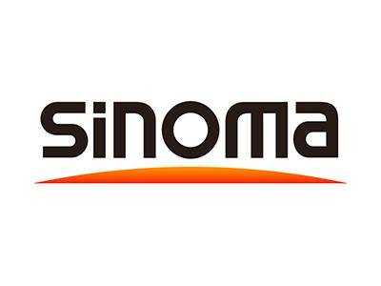
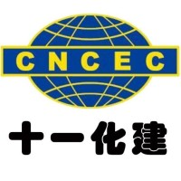
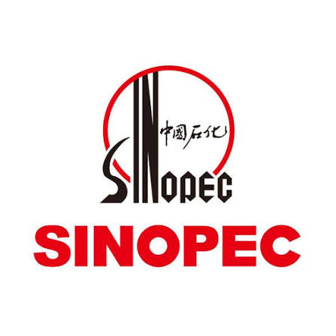

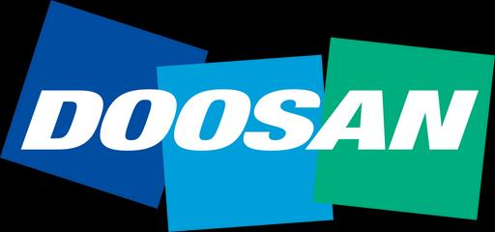
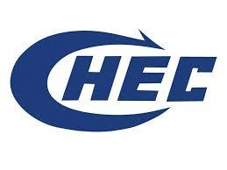



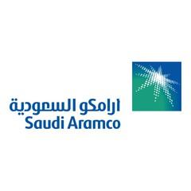



Projects Gallery: A Look at What We've Delivered
NAWAF ELITE ESTABLISHMENT FOR CONSTRUCTING
PAGE 17

▪
NAWAF ELITE ESTABLISHMENT FOR CONSTRUCTING
PAGE 18

Projects Gallery: A Look at What We've Delivered

Thank You
Thank you for your interest. We look forward to working with you.
VISIT US
King Abdulaziz Street, Jubail 35514, Saudi Arabia

info@nawaf–neec.com

+966 053 983 7423
+966 057 161 1837
C O N T A C T S U S
Al Jubail – kingdom Of Saudi Arabia

www.nawaf–eec.com

